EduGenie
Google Gemini Powered Learning Assistant
DEMO VIDEO – SCREEN DEMONSTRATION & VOICE EXPLANATION SCRIPT
This document is designed for recording a live demonstration of the EduGenie application. The presenter should operate the actual website while explaining the features in their own voice. The screenshots below are taken from the supplied sample project document.

1. Project Introduction
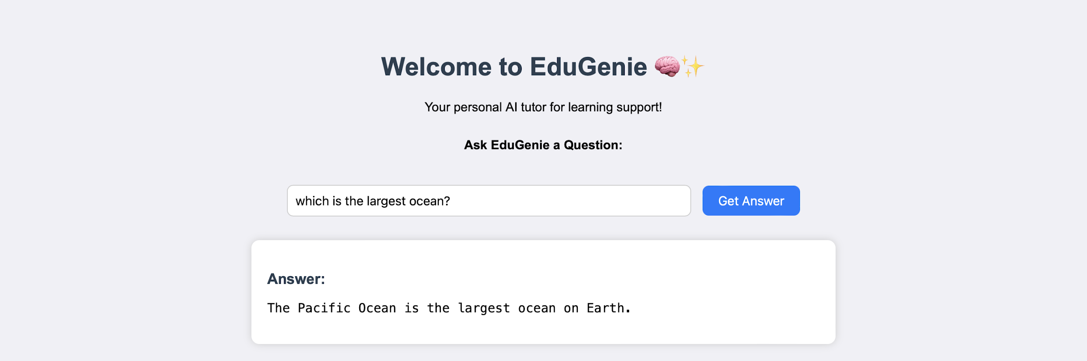
Figure 1. EduGenie web application – sample homepage/Q&A interface.
Show: Open the EduGenie homepage.
Say: “Hello everyone. Today I am going to demonstrate my project, EduGenie, which is a Google Gemini powered learning assistant. EduGenie is designed to make learning easier and more interactive. It allows students to ask questions, understand complex concepts, generate quizzes, summarize educational content, and receive personalized learning recommendations.”
The supplied project document describes EduGenie as a lightweight AI-powered educational assistant built with FastAPI and a simple HTML and CSS frontend. fileciteturn0file0L17-L24

2. How the Program Works
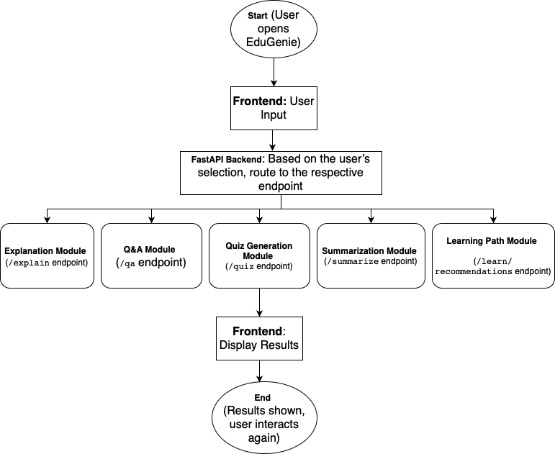
Figure 2. Sample architectural flow of the EduGenie system.
Show: Briefly show the architecture and then return to the website.
Say: “The basic workflow is simple. The user enters a learning request through the web interface. The frontend sends the request to the FastAPI backend. The backend sends the request to the appropriate feature module and the AI service processes it. The generated result is then returned to the frontend and displayed to the user.”
The project document identifies separate modules for explanation, Q&A, quiz generation, summarization, and learning recommendations, together with FastAPI endpoints. fileciteturn0file0L95-L114 fileciteturn0file0L145-L151

3. Q&A Demonstration
Figure 3. Sample Q&A result displayed in the EduGenie website.
Show: Click Q&A and type: “Which is the largest ocean?” Then click Run EduGenie.
Say: “First, I am going to demonstrate the question-and-answer feature. A student can enter an academic or general learning question. When I submit the question, the request is processed by the backend and the AI generates the answer. This is useful when a learner has a doubt and wants a quick explanation.”
The supplied document gives a similar ocean question as a project scenario and describes the Q&A module. fileciteturn0file0L25-L28 fileciteturn0file0L126-L129

4. Concept Explanation Demonstration
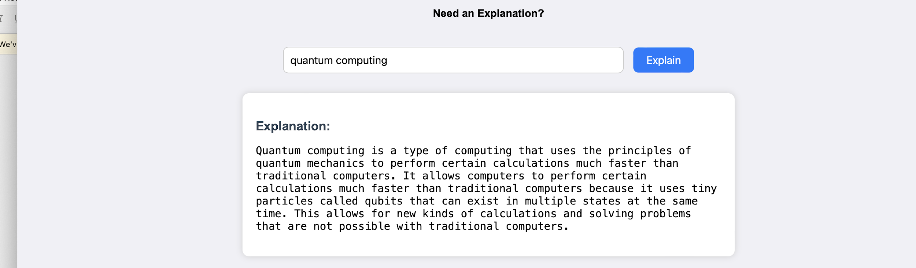
Figure 4. Sample concept explanation result.
Show: Click Explain. Type: “Explain the Pythagoras theorem with a simple example.” Then run it.
Say: “Next is the concept explanation feature. This is useful when a student knows the topic but finds the concept difficult to understand. Here I am asking EduGenie to explain the topic using simple language and an example. The purpose is to break a complex topic into an easier form.”
The supplied document describes the explanation module as producing concise, context-aware educational explanations. fileciteturn0file0L120-L125

5. Quiz Generation Demonstration
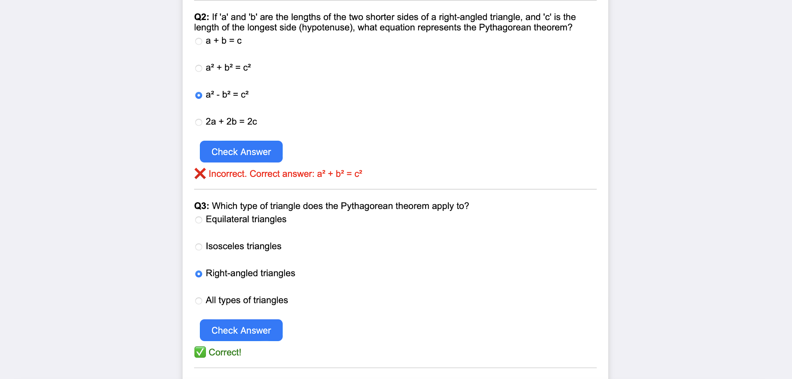
Figure 5. Sample quiz interface with generated questions and answer feedback.
Show: Click Quiz. Paste a short study passage and click Run EduGenie. Select one answer.
Say: “The third feature is quiz generation. Here I provide study material as input. EduGenie analyzes the passage and generates three multiple-choice questions. Each question contains four options. I can select an option and the application immediately indicates whether my answer is correct and shows the correct answer when necessary.”
The project document specifies three MCQs with four options each and structured output for integration. fileciteturn0file0L130-L134

6. Summarization Demonstration
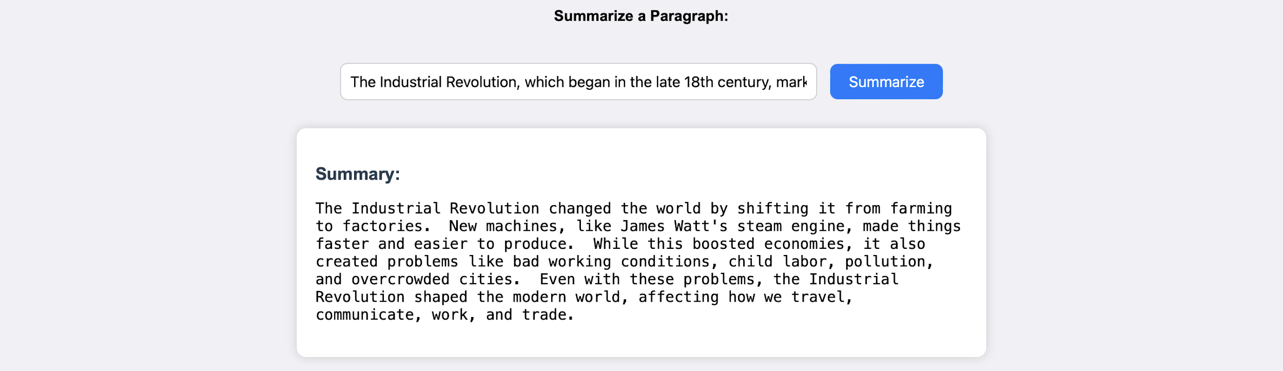
Figure 6. Sample summary generated by EduGenie.
Show: Click Summary. Paste a longer educational paragraph, choose the desired length, and run it.
Say: “The fourth feature is summarization. Students often have large amounts of study material to revise. Instead of reading the complete passage every time, they can provide the content to EduGenie and generate a shorter version. The feature is designed to retain important information while removing unnecessary repetition.”
The supplied document describes the summary module as using Gemini to turn long educational passages into concise versions while retaining core information. fileciteturn0file0L135-L138

7. Personalized Learning Path Demonstration
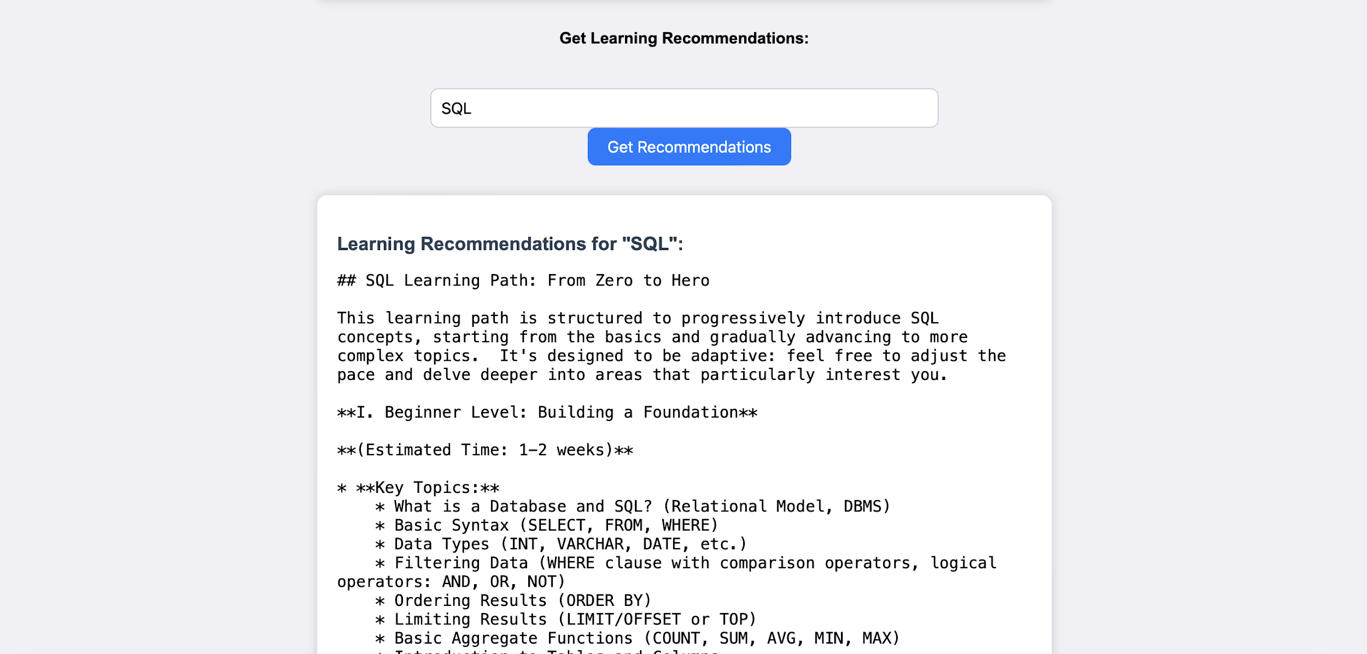
Figure 7. Sample learning recommendations generated by EduGenie.
Show: Click Learning Path. Type: “SQL from beginner to advanced.” Select Beginner and 5 hours/week. Run it.
Say: “The final feature is the personalized learning path. Here I enter the topic I want to learn, select my current level, and specify the amount of time I can study each week. EduGenie then generates a structured learning path and guidance for progressing through the topic.”
The supplied document describes learning recommendations as a structured path that adapts to the learner’s level. fileciteturn0file0L140-L143

8. Technical Implementation
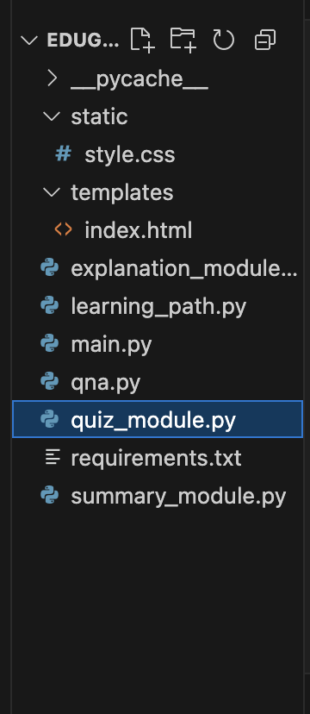
Figure 8. Sample EduGenie project folder structure.
Show: Briefly switch to VS Code and show main.py, qna.py, explanation_module.py, quiz_module.py, summary_module.py, learning_path.py, templates/index.html and static/style.css.
Say: “Now I will briefly explain the technical implementation. FastAPI is used for the backend and the frontend is built using HTML and CSS. The application is divided into separate modules so that each major learning feature has its own logic. The backend exposes REST API endpoints for Q&A, explanation, quiz generation, summarization, and learning recommendations.”
The supplied document lists the folder architecture and FastAPI endpoints. fileciteturn0file0L95-L114 fileciteturn0file0L145-L152

9. Running the Application
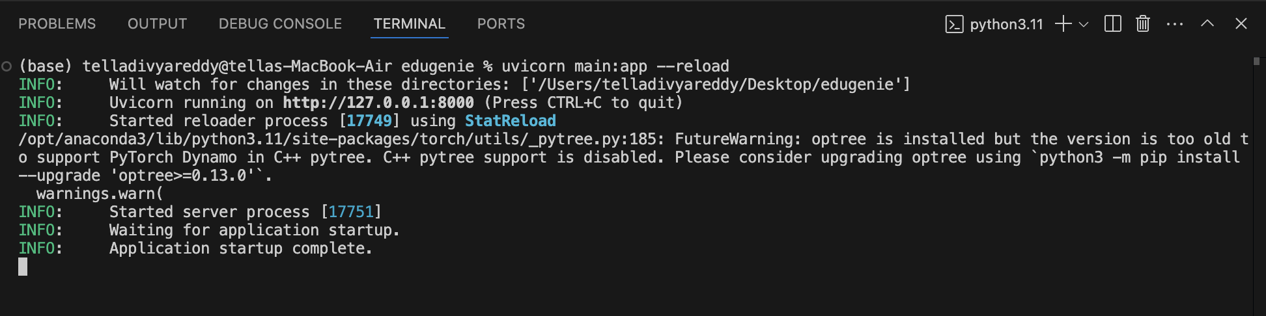
Figure 9. Sample terminal showing the local application running.
Show: VS Code terminal.
Say: “The application can be run locally using Uvicorn.”
Command: uvicorn main:app --reload
Then open: http://127.0.0.1:8000
The supplied document gives the same local run command and browser address. fileciteturn0file0L172-L177

10. Live Integration Explanation
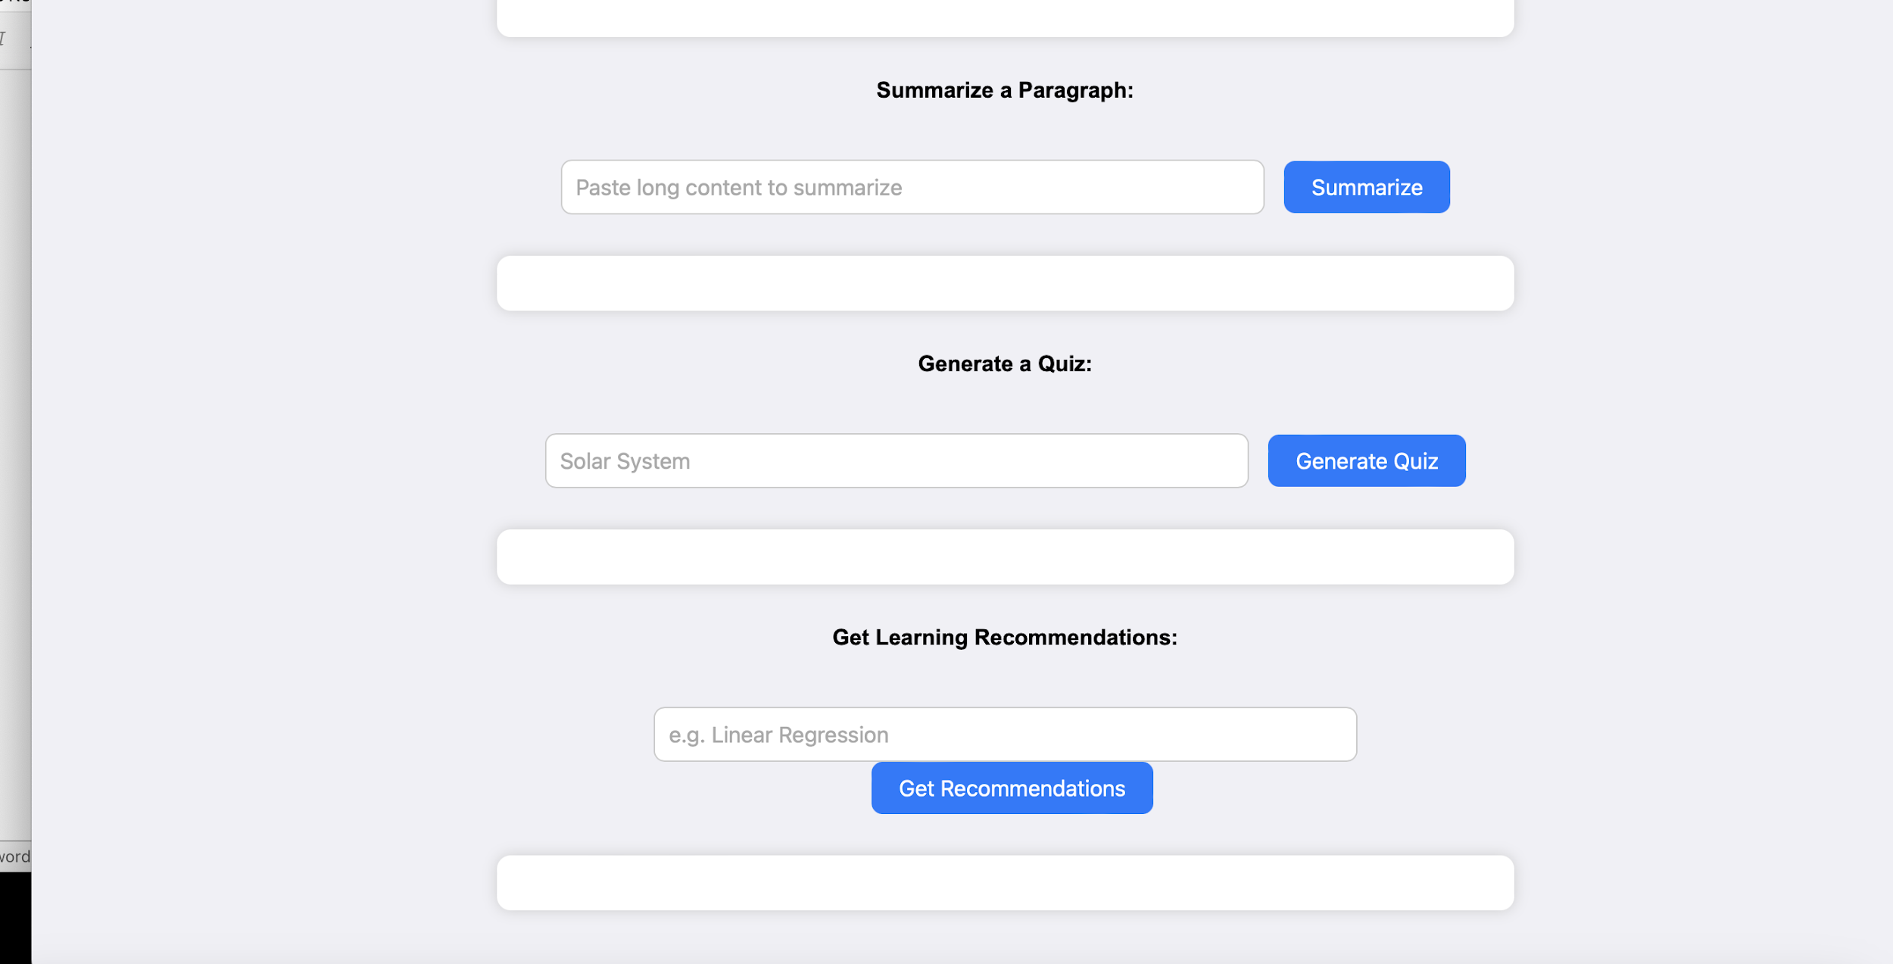
Figure 10. Sample EduGenie interface showing multiple learning functions.
Show: Return to the browser and perform one final request.
Say: “This demonstrates the live integration between the frontend and backend. When I submit a form, the frontend sends a POST request to the FastAPI backend. The backend processes the request through the appropriate module, communicates with the AI service, and the result is displayed back in the web interface.”
The supplied document describes form submission as a POST request to the FastAPI backend with the result appearing in the web interface. fileciteturn0file0L157-L170

11. Closing
Show: Return to the EduGenie homepage.
Say: “To conclude, EduGenie brings several learning activities into one AI-powered application. It can answer questions, simplify concepts, generate quizzes, summarize study material, and create learning recommendations. The project combines a simple web interface, FastAPI backend, and generative AI to provide an interactive learning experience.”
The supplied project document concludes that EduGenie is an accessible AI-powered educational assistant for interactive and personalized learning. fileciteturn0file0L229-L236

12. Demo Recording Checklist
- Open the EduGenie website.
- Introduce the project.
- Show the overall interface.
- Demonstrate Q&A.
- Demonstrate Concept Explanation.
- Demonstrate Quiz Generation and answer one question.
- Demonstrate Summarization.
- Demonstrate Personalized Learning Path.
- Briefly show the VS Code project structure.
- Explain the Frontend → FastAPI → AI → Frontend workflow.
- Show the running terminal only if required.
- Return to the website and conclude.

13. Important Note
The screenshots above are figures extracted from the supplied sample project document. For your final video, it is better to use screenshots captured from your own currently running EduGenie application so that the interface and results exactly match the version you demonstrate. The supplied document contains older model terminology, so describe the model configuration that is actually enabled in your current application.

Conclusion
EduGenie has been developed as a robust and accessible AI-powered educational assistant that seamlessly integrates cloud-based intelligence with an intuitive, low-footprint web interface. Designed to support self-learners, educational institutions, and content platforms, EduGenie democratizes learning by simplifying complex concepts, providing instant question-and-answer interactions, generating personalized quizzes, offering detailed summaries, and tailoring smart learning paths based on individual needs. Its lightweight infrastructure ensures that even users with minimal hardware resources can access high-quality, personalized education without barriers.
Throughout the development of EduGenie, the project achieved key milestones in AI integration, user experience design, and content adaptability. Leveraging advanced generative AI, it transforms static learning into a dynamic and interactive process. The platform's simplicity and clarity cater to learners of all levels—especially those who may find traditional educational content overwhelming or inaccessible. The modularity of the platform further allows for easy future upgrades, while its cloud-based backend ensures scalability and data-driven intelligence.
However, the development journey came with its own set of challenges. Ensuring accuracy in AI-generated responses, maintaining performance across devices, and balancing personalization with general usability were significant hurdles. Overcoming these required continuous testing, fine-tuning AI prompt structures, optimizing the UI for clarity, and addressing data privacy concerns. Yet, these challenges provided valuable learning outcomes—especially in areas like prompt engineering, cloud integration, user-centric design, and scalable architecture.
Looking ahead, EduGenie holds immense potential for enhancement and expansion. One promising direction involves the integration of voice-based interaction, enabling users to learn hands-free using spoken commands and queries—a particularly useful feature for accessibility and multitasking. Multilingual support is another key frontier, helping bridge language barriers and reaching a broader global audience. A mobile application is also envisioned to make learning available anytime, anywhere, with offline features for uninterrupted access.
Furthermore, future iterations of EduGenie could incorporate progress tracking dashboards, allowing users to visualize their learning journey through metrics and insights. The addition of gamified elements such as badges, learning streaks, and challenge-based assessments can boost engagement and motivation. Adaptive learning paths powered by data analytics can guide users more intelligently through content based on their strengths and weaknesses.
From a collaboration perspective, EduGenie can evolve to support group study sessions, teacher or parent dashboards, and integration with Learning Management Systems (LMS) such as Moodle or Google Classroom. Input recognition for images and PDF files can expand how students interact with content, enabling snapshot-based doubt solving and resource summarization. Real-time sync and smart notifications will also improve continuity and interactivity.
In conclusion, EduGenie is not just an AI tool—it’s a foundation for the future of personalized, inclusive, and intelligent education. By bridging gaps in access, comprehension, and adaptability, it redefines the learning experience for digital natives and underserved communities alike. As it continues to evolve, EduGenie is poised to become a comprehensive learning companion for the modern era—smart, scalable, and learner-first.

